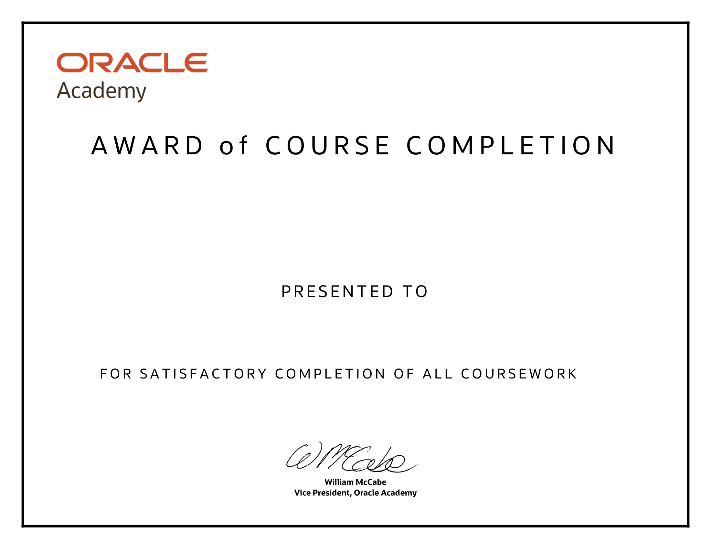

SIBISUNDAR L 220701277

Database Programming with PL/SQL

12th April 2024